Adaptive ICU Patient Deterioration Prediction using Temporal Deep Learning and Explainable AI

C Kovendhan
Dept of Computer Science and Engineering
vels institute of science, technology and advanced studies
chennai, India
kovendhan1321@gmail.com
K U Kanmani
Dept of Computer Science and Engineering
vels institute of science, technology and advanced studies
chennai, India
kukanmani06@gmail.com
Mohamed Anas M
Dept of Computer Science and Engineering
vels institute of science, technology and advanced studies
chennai, India
mmohamedanas235@gmail.com
G.Revathy*
Dept of Computer Science and Engineering
vels institute of science, technology and advanced studies
chennai,India
revathy.se@vistas.ac.in

*Corresponding author email id : revathy.se@vistas.ac.in
Abstract— Patient condition can get worse slowly in an intensive care unit, but it's not always easy to detect this early on. A machine that can look at a patient's records can give an early sign that the patient needs more attention. This paper introduces an adaptive system for predicting patient deterioration in the ICU. It uses scientific time series data from the eICU Collaborative Research Database. The system uses patient details, vital signs, lab results, treatment information, and other medical observations. The data is cleaned, organized by patient and time, and transformed into a standard format for machine learning,Logistic Regression and Random Forest are used as baseline methods, while XGBoost is the main machine learning model. A GRU-based time-series model is also used for comparison. The prediction is made for 6-hour, 12-hour, and 24-hour time frames. The system uses accuracy, F1-score, and ROC-AUC for evaluation, along with visual analysis through confusion matrices and ROC curves. Explainable AI is used via SHAP to show which clinical factors contributed to a prediction. The output isn't a diagnosis but a risk estimate that can be shown on a medical dashboard to help healthcare professionals make decisions.

Keywords--ICU deterioration prediction, eICU Collaborative Research Database, temporal deep learning, LSTM, GRU, XGBoost, explainable artificial intelligence, SHAP, clinical decision support.

Introduction
Patients in the ICU are in critical condition and need constant monitoring. Their vital signs which is heart rate, blood pressure, oxygen levels, breathing rate, temperature, and brain activity, are checked regularly. Lab results are also assessed during their stay in the hospital. These observations and how the patient's condition changes over time show the general health status. Deterioration can happen quickly and needs to be noticed so that medical teams can take action before worse events happen. Also, small gradual changes may lead to health worsening. In ICUs, deterioration is usually managed through bedside monitoring, clinician assessments, regular checks, and early warning systems. Although these are effective, electronic health records can store more valuable data about the patient’s health. So this project aims to create an early warning system using the Collaborative Research Database. The main focus is predicting patient deterioration at three times: 6, 12, and 24 hours. The project includes data preparation, feature engineering, creating time-series data for model training and testing, evaluating model performance, and interpreting the results. XGBoost is used for analysis. A Gated Recurrent Unit checks if deep learning can find meaningful patterns in the data. Finally, there's a description of a dashboard that visualizes the risk prediction, the model's confidence, and the most important factors influencing the result. The data trends are easy to understand for humans. It was found that collaborative databases often have missing data, irregular time stamps, and repeated records. These issues make time-series predictions hard and can lead to misleading results if data leakage occurs. That is, if future data is used in the training set or if the same patients are used for both training and testing, the two groups are not independent and the findings can be biased. Therefore, this project carefully handles the data to make sure the training and testing sets don't overlap, using time-based splitting and other methods.

Literature Survey
Mili et al. [1] did a study on predicting ICU mortality using Long Short-Term Memory networks. Their work showed how effective these networks can be in learning patterns from clinical time-series data for different observation periods. This study can serve as a foundation for developing a method to predict changes in ICU conditions.

Clinical model for dynamic ICU mortality prediction based on bidirectional LSTM, which is time-aware. Predicted by Wang et al. [2] The work involves looking at the time differences between clinical observations when training the algorithm. The paper is directly connected to the proposed system because changes in time seen in ICU conditions can be used to predict mortality.

Aly et al. [3] Introduced E-CatBoost a machine learning framework for predicting mortality in the ICU, which uses the eICU collaborative research database. The research suggests that the e-ICU database is a good source of data for building a similar system.

Ahmed et al. [4] did an analysis on predicting sepsis in ICU patients using machine learning. This study, which uses XGBoost to find important features, can serve as a basis for a similar approach in the proposed system.

Vashisht et al. [5] did an analysis on predicting patient deterioration in the ICU using data mining. This study, which uses sequential analysis for predicting deterioration, can be used as a foundation for the proposed system.

Pollard et al. [6] presented the e-ICU collaborative research database as a free resource for critical care research. The work describes how patient records of their conditions and treatments are collected while they are under ICU observation. The paper provides the necessary dataset for analysis, which forms the basis for developing the proposed ICU deterioration prediction system.

Chen and Guestrin. [7] introduced XGBoost: a fast and accurate method for linear regression on large-scale data. This study, which uses XGBoost for feature importance identification, can serve as a basis for a similar approach in the proposed system.

Cho et al. [8] presented a study on gated recurrent networks for language models. The paper provides the basis for developing the proposed ICU deterioration prediction system by supplying the rationale on the use of GRU cells for pattern identification in time-series data.

Unified approach to interpreting model predictions. Predicted
by Lundberg and Lee [9]. The article describes the use of Shapley values for explanation of the rationale behind each prediction made by a machine learning model. The study can be used as a basis for implementing explanation modules in the proposed system, as it provides insights into the interpretation of features’ importance.

Chung et al. [10] introduced gated recurrent neural networks for language models. The paper explores the application of recurrent neural networks with gated units for sequential data analysis and describes their advantages. The study can be used as a basis for implementing RNNs in the proposed system, as it provides insights into the advantages of recurrent networks.

Research Gap
A significant portion of the research into predicting ICU admissions is concerned with mortality, the length of stay, or a particular condition like sepsis. Although these outcomes are important, they do not entirely address the wider issue of ICU monitoring—that is, whether the patient’s condition is starting to deteriorate and whether this can be picked up early enough to be of use. A further limitation is the fact that conventional machine learning and temporal deep learning are separate. In some studies, structured clinical features are used; in others, sequential networks are used. There are few practical systems that incorporate both methods within the same workflow, using the same data preparation and evaluation criteria. It is useful to carry out a comparison since this shows whether the extra complexity of a temporal model is worth the improvement in results. It is important that models are interpretable in a clinical context since a simple probability does not show why the model has given a high-risk result.

Doctors and healthcare professionals might want to know whether the prediction was affected by a high heart rate, low oxygen saturation, an abnormal laboratory value or a change in another measurement. In this project, SHAP is used to make the model’s output more inspectable. In the end, many research prototypes stop at the model score. A practical software system also includes a clear presentation layer which shows the current risk, the prediction horizon, the important contributing variables and, where appropriate, the recent trend. The proposed work brings all these elements together in a single pipeline: time-aware preprocessing, model comparison, explainability and dashboard presentation.

Dataset And Proprocessing
A. Dataset Description

The project uses the e-ICU Collaborative Research Database extracted from PhysioNet. The database consists of clinical data from intensive care units with patient demographics, vital signs, laboratory, medication, and other information. Remarkably, the dataset is multi-centred, which is especially critical for the current research as it is focused on prediction models in different facilities.

B. Data Cleaning

The initial database undergoes a cleaning process before the prediction model. The data cleaning procedure encompasses data type identification, removing duplicates and irrelevant data, extreme value detection, and reorganisation of the database into a timeline-based structure. The last step is justified as in ICU, the majority of variables are recorded at irregular intervals.

It is especially important to utilise the training set to fit the imputation model, which subsequently addresses the missing values in the test and validation sets. Remarkably, in both sets, the data cleaning process is applied, which inevitably makes the test set aware of the training data, thus resulting in information leakage.

C. Feature Selection and Engineering

The current project considers various features associated with ICU patients, including heart rate, blood pressure, oxygen saturation, respiration, temperature. Glasgow coma scale, laboratory findings, and patient demographics from the preprocessed dataset.

D. Leakage Prevention

Leakage is a serious concern in predictive modelling, especially when working with clinical data. Bearing that in mind, the current project ensures that a single patient is not represented in more than one partition, which could make the test set aware of the training data. Additionally, leakage is prevented through the application of the same transformations (e.g. scaling) to the validation and test sets that were estimated on the training set. Also, note that the model only receives the information that was available at a given time in the timeline-based records, meaning that it cannot utilise future observations as proxies for past ones.

Proposed System
The proposed system takes as an input the previously prepared intensive care unit observations and outputs the estimate of the deterioration risk for the chosen prediction horizon. The system will go through such stages as data collection, pre-processing, feature engineering, temporal sequence generation, model training, risk estimation, explanation, and visualization.

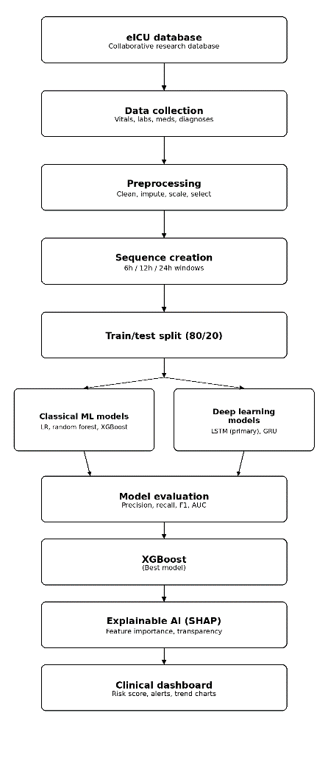
Fig 1. Proposed workflow for ICU risk prediction using clinical data preprocessing, machine-learning models, explainable AI, and dashboard visualization.

Phase 1: Data Collection

eICU dataset PyshioNet : https://physionet.org/content/eicu-crd-demo/get-zip/2.0.1/
Clinical indicators, including vital signs, laboratory tests, medications, and diagnoses were extracted from the eICU database. All the relevant records were arranged in a way that the patient’s ICU stay was in order to make sure that each patient’s clinical progress is considered during modelling.

Phase 2: Data Preprocessing

The collected data was preprocessed to remove irrelevant, redundant and duplicated information, and prepare for model training. It involved the following steps:
Removal of duplicated and irrelevant information. Conversion of measurements into a comparable format. Imputation of missing data points using relevant statistical methods. Normalization of numerical data and encoding of categorical data. Removal of irrelevant, inappropriate and highly redundant features.

Phase 3: Sequence Creation

The preprocessed clinical information was arranged into clinical sequences of 6, 12, and 24-hour intervals. It allowed for identifying short-term and long-term indicators of deterioration.

Phase 4: Train/Test Split

The data was split into training and testing sets in a ratio of 8:2 to ensure that the model generalizes well upon deployment. The split was based on patients, to make sure that the clinical records of one patient are not split between the training and testing sets.

Phase 5: Model Development

Several machine learning and deep learning models were trained on the preprocessed and split dataset. The following algorithms were tried. Logistic Regression, Random Forests and XGBoost – For tabular data. LSTM and GRU – For temporal data.

Phase 6: Model Evaluation

The performance of the different models was evaluated and compared using precision, recall, F1-score, and ROC-AUC. It allowed to determine which algorithm has the best capacity to distinguish between positive and negative classes.

Phase 7: Final Model Selection

The best-fitting model for the task at hand is selected based on the results of the evaluation. If the results indicate that XGBoost has the best performance metrics among the machine learning algorithms, it is chosen as the best model for determining the risk of deterioration.

Phase 8: Explainable AI

SHAP is used to identify the most influential features in the model and explain its predictions. It helps in understanding what factors mostly contribute to the development of deterioration and how a particular patient’s risk profile compares to others.

Phase 9: Clinical Dashboard

The risk scores determined by the final model are then presented in a clinical dashboard, which highlights the risk status, alerts, relevant features, and trends for each patient. The dashboard can be used to inform clinical decisions.

System Implementation
A. Data Pipeline

Once the eICU data are loaded, the necessary variables for the prediction task are picked, and the dataset is cleaned.
The data are then sorted by patient and time and changed into the format that the models need.

B. Sequence Construction

The clinical data are arranged into sequences based on the time they were recorded. The project uses a 24-hour time period for the temporal component and applies one of three prediction timeframes (6 hours, 12 hours, or 24 hours) for the labels.
The same sequence and labeling method is used in all experiments.
Target creation is done separately for each prediction timeframe.

C. Training and Validation

We split the data by patient into training, validation and test groups. The training group trains the models; the validation group. Compares models. The test group evaluates the models. Splitting by patient reduces the risk that the models will use observations from the same patient in both the training and validation groups.

D. Prediction and Explanation

After training the selected model gives a predicted class and a probability, for each test input; the predicted class is used to compute evaluation measures;. The probability can be shown on the dashboard. SHAP can then be used on each prediction to identify the features that determine the result and whether they increase or decrease it.

E. Results and Discussion

The project results show that the system can be trained for prediction timeframes but the scores differ for each model and each timeframe.

The current experiments report F1-score, recall and ROC-AUC because these measures are important for datasets that might have classes which is shown in Table 1.

TABLE 1.PERFORMANCE EVALUATION BASED ON METRICS F1-SCORE,RECALL AND ROC-AUC
Horizon | Model | F1-score | Recall | ROC-AUC
12 hours | XG Boost | 0.0781 | 0.1754 | 0.8390
24 hours | GRU | 0.1366 | 0.1818 | 0.7214
6 hours | XG Boost | 0.0317 | 0.0741 | 0.8740

The 6-hour XGBoost experiment had a ROC-AUC of 0.8740, F1-score of 0.0317 and recall of 0.0741.

The high ROC-AUC combined with F1 and recall suggests that the model can classify the data but the model performance is limited at the specific operating point used for these results is depicted in Figure 2.

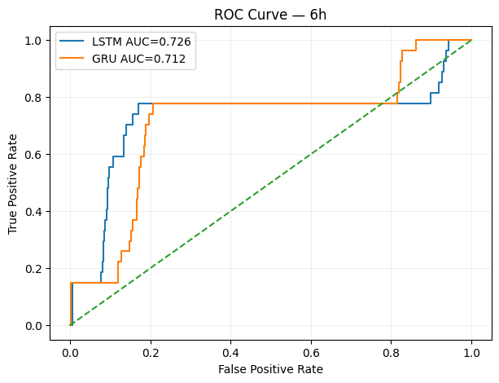
Fig 2.ROC-AUC for 6 hours

For the 12-hour XGBoost experiment the ROC-AUC, F1-score and recall are 0.8390, 0.0781 and 0.1754 the model performance is limited at the specific operating point used for these results is depicted in Figure 3.

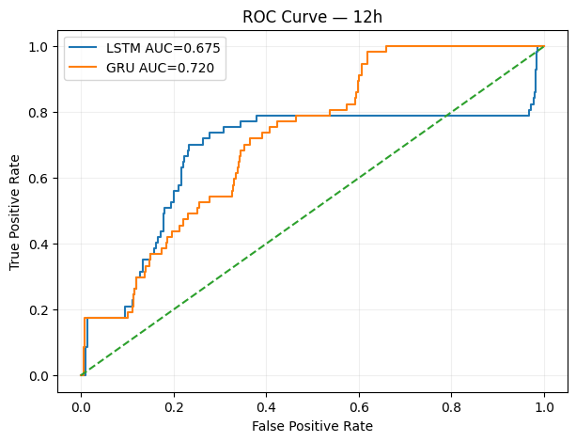
Fig 3.ROC-AUC for 6 hours
The 24-hour GRU experiment had F1-score of 0.1366,recall of 0.1818 and ROC-AUC of 0.7214 the model performance is limited at the specific operating point used for these results is depicted in Figure 4.

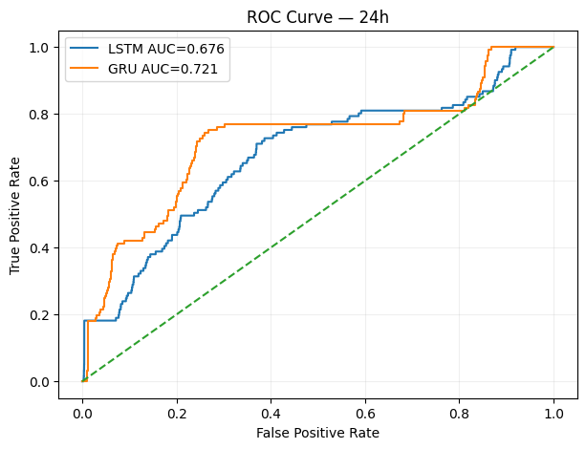
Fig 4.ROC curve for 12 hours

These results should not be seen as a ranking of models because the prediction timeframes are different. So the results cannot be combined into one performance measure. A model might have a ROC-AUC but low recall at a certain operating point. Future work can look into the reasons, by trying threshold choices class weightings and probability calibration.

Challenges Faced
The eICU database contains many tables and variables with different clinical information, so identifying the relevant fields required to check. Since the readings are recorded at irregular intervals, generating consistent hourly or sequence-based data can be challenging. Missing values were also common. Not every patient had all tests done, and the absence of a measurement doesn’t always mean the value was normal. The preprocessing process had to be carefully chosen and applied consistently. Clarifying the deterioration label was important.
The project had to differ between the input observations and the future time period used to make the label. Class imbalance, computation cost, model choice, and patient-level leakage were other issues during the implementation.

Conclusion
This paper proposed an innovative framework for intensive care unit (ICU) patients’ deterioration prediction based on clinical time-series data mining, machine learning, temporal deep learning, and explainable artificial intelligence methods.
The framework was evaluated on the eICU collaborative database research hospital to predict the risk of deterioration within 6 hours, 12 hours, and 24 hours. The model uses the XGBoost implementation, where a GRU layer is added to the input data interpretation to optimize the temporal information. The model was interpreted using the SHAP (SHapley Additive exPlanations) method and visualized in a dashboard.
The current analysis demonstrated that the proposed framework could effectively predict the risk of deterioration. However, there is a need for caution when generalizing the model performance, as the evaluation used the threshold that maximizes the ROC-AUC metric. Although the ROC-AUC scores were relatively high, ROC-AUC alone does not provide a complete measure of model performance. Recall and F1-score are also important, particularly when evaluating the model at a specific classification threshold. Future work should explore suitable classification thresholds and validate the model’s performance on an independent dataset.
The framework should be considered a supportive tool for the ICU clinicians in their decision-making process and not as a replacement for the medical expertise. Before the model is used in a real clinical, further testing and validation are required to verify the findings.
Finally, there is a need for future studies to optimize the model for production by addressing the data privacy concerns, optimizing the model for concept drift, and designing an adequate model feedback loop for correcting the model’s predictions.

Future Enhancements
More research can be done to find a more effective method of handling clinical data that is not regularly collected. This can include using attention-based recurrent networks or transformers. It would also be useful to test how different factors affect the outcome of the model, such as the length of the sequence, the frequency of the data, which features to include, or how to handle class imbalance, Testing different algorithms, such as XGBoost, GRU, and others, with same features and test sets would highlight their differences.
The dashboard can be improved by including patient timelines, triggered alerts, an explanation of model's output, user roles and encrypted data access. If the system is going to be used in a real-world setting, it should have user authentication, activity monitoring, data privacy and encryption, and medical review. The evaluation can be improved by constructing precision-recall curves, finding optimal thresholds, determining the model's confidence, having confidence intervals, and testing the model on different datasets.

Refrences
- M.Mili, A.Kerkeni, A.Ben Abdallah, and M.H.Bedoui, “ICU Mortality Prediction using Long Short-Term Memory Networks,” 2023.
- J.Wang, X.Zhao, X.Chen, et al., “Development and Validation of a Dynamic Real-Time Risk Prediction Model for Intensive Care Unit Mortality Using Time-Aware Bidirectional LSTM,” 2025.
- H.A.Aly, M.A.Elhoseny, et al., “E-CatBoost: An Efficient Machine Learning Framework for Predicting ICU Mortality Using the eICU Collaborative Research Database,” 2022.
- F.Ahmed, A.M.Kassem, et al., “Early Prediction of Sepsis in Intensive Care Patients Using Machine Learning,” 2023.
- R.Vashisht, B.Jung, et al., “ICU Patient Deterioration Prediction: A Data Mining Approach,” 2015.
- T.J.Pollard, A.E.W.Johnson, J.D.Raffa, et al., “The eICU Collaborative Research Database, a Freely Available Multi -Centre Database for Critical Care Research.” Scientific Data,vol5,2018.
- T.Chen and C.Guestrin, “XGBoost: A Scalable Tree Boosting System,” in Proc.22nd ACM SIGKDD Int.Conf.Knowledge Discovery and Data Mining, 2016.
- K.Cho et al., “Learning Phrase Representations Using RNN Encoder–Decoder for Statistical Machine Translation,” in Proc.EMNLP, 2014.
- S.Lundberg and S.-LLee, “A Unified Approach to Interpreting Model Predictions,” in Advances in Neural Information Processing Systems,2017.
- J.Chung, C.Gulcehre, K.Cho, and Y.Bengio, “Empirical Evaluation of Gated Recurrent Neural Networks on Sequence Modeling,” 2014.

IEEE conference templates contain guidance text for composing and formatting conference papers. Please ensure that all template text is removed from your conference paper prior to submission to the conference. Failure to remove template text from your paper may result in your paper not being published.

